|  |  |
| --- | --- |
|  | Malawi Government |

**NKHOTAKOTA DISTRICT AGRICULTURE OFFICE**

**BACKSTOP AND FACILITATE ESTABLISHMENT OF INTEGRATED HOMESTEAD FARMING (IHF) 2.1.5.4**

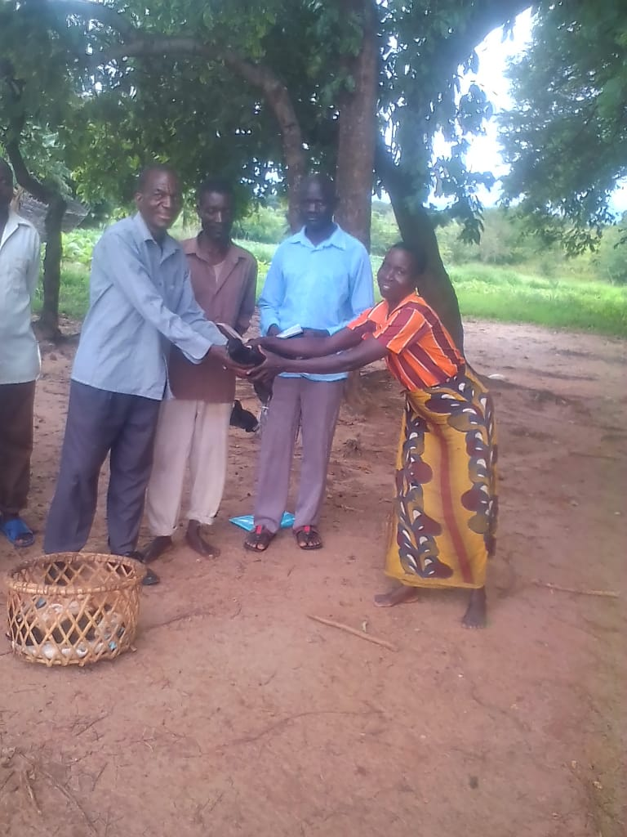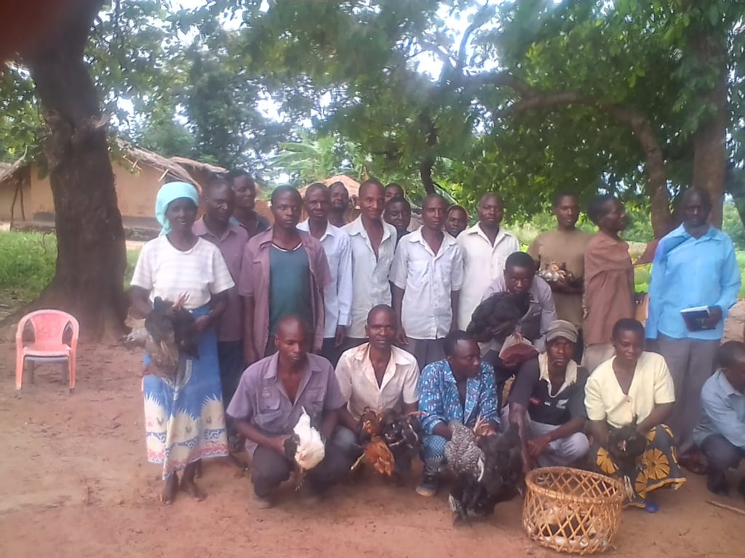

***Chicken pass on as a way of promoting small stock production component in IHF in Mwasambo EPA***

***Compiled By***

**Luke DZ Kamonde**

**18rd DECEMBER, 2018**

**Introduction**

Integrated Homestead Farming (IHF) is the growing of diversified crops and rearing of small stock or aquaculture around the home for improving food security and nutrition. IHF provides simple food-based approaches to resolving nutrient deficiencies through successful establishment and management of integrated farming at household, institutional and community settings. Nkhotakota district agriculture office is one of the intuitions which are promoting IHF in across the district of Nkhotakota. For proper implementation of IHF there is need to technically backstop the implementation of the interventions by Subject matter specialists as front line staff establish IHF.

The department of extension in liaison with other technical department organize an activity to establish IHF among selected households in the district. The resources for the activity were drawn from SAPP activity 2.1.5.4 in first quarter of 2018-2019 financial year. A total of 365 (265 Males and 100 Females) farmers were trained on IHF.

**Objective**

* To impart knowledge and skills in vegetables, fruit and small stock production.
* To let the participants, know the importance of fruits, vegetables and small stock at household level.
* To increase adoption of the approach among the farmers.

Expected outcome of the training:

* Every household will have backyard garden, fruits and small stock around the homestead
* Increased adoption good agricultural practices which will lead to high production uptake of nutritious foods

**Procedure**

* Orientation of the households on integrated homestead farming where the components of IHF were outlines. The outlined components include: small stock production, Vegetable production, diversified staple food crops and fruit production.
* Mounting of demonstrations on vegetable production, fruit production and small stock production.
* Promoted small stock production whereby pass on of chicken was arranged and conducted during the orientation of households on IHF.
* Follow ups on the progress of orchard establishment from previous seasons

**Participants Feedback during orientation and field demonstrations**

* Participants appreciated as they will be able to promote production and consumption of micro nutrients rich crops and small stock livestock
* All topics were fully covered and participants liked them though some farmers demanded for an extension of the program to reach out to many households
* Participants assured to start immediately implementing what they have gained

**General Observation and recommendations**

In most household good agricultural practices were followed while in some households they were not fully adopted. Those who were following GAP they were encouraged to continue doing so. For those who were not following GAP demonstrations were mounted for them to appreciate so that they can practice in their respective households. The demonstrations included demonstrations on backyard gardening in terms of bed making and even planting in sacks; standard housing for chickens and goats**.**

The interventions being implemented in the households included, fruit production, small stock production and backyard gardening. These households were also encouraged to be participating in cooking demonstrations so that they can make effective use of their produce.

**Way forward**

* For those households which received fruit trees seedlings they were advised to keep on watering the seeding and protect them from damage by different livestock species
* Routine vaccination of chickens against Newcastle.